Friends of Northern Lake Champlain
Request for Proposals
April 22, 2022

Falls Road Trail Site Assessment

- Introduction

Falls Road Trail is an approximately 0.9-mile dirt trail in Georgia, VT. It interests with Mill River Road to the north and Cline Road to the South. Falls Road Trail is located adjacent to the most impaired portion of Mill River, less than a mile from the Mill River delta in St. Albans Bay. According to the Vermont 303(d) List of Impaired Waters, agricultural runoff, streambank erosion, nutrients, and sedimentation/siltation have caused this section of the Mill River (“Mill River, from St. Albans Bay to 1.8 Miles Upstream”) to not meet the Vermont Water Quality Standards. The surface water is impaired where a total maximum daily load (TMDL) is required. Therefore, Additionally, soil erosion from the trail is contributing considerable phosphorus loads to Mill River, and thus Lake Champlain.
Since the Town of Georgia reclassified the Falls Road to Trail status, adjoining landowners and the Georgia Conservation Commission have sought solutions to prevent further deterioration of this trail. The purpose of this project is to provide an accurate assessment and identify and select a list of appropriate best management practices (BMPs) to reduce stormwater runoff and subsequent soil erosion along the Falls Rd Trail.
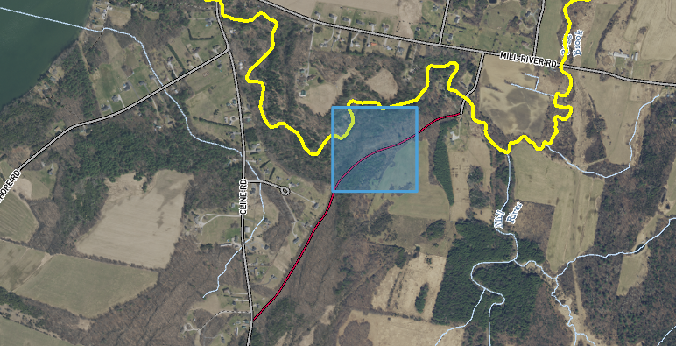
Photo 1. Site map of the Falls Road Trail site. The red line represents the Falls Road Trail, the blue square represents the area of concern (44.774571, -73.136238), and the yellow line represents the impaired portion of Mill River.

- Scope of Work

The purpose of this proposed project is to assess the site for potential BMPs that will reduce erosion and further deterioration of the Falls Road Trail. FNLC will partner with an environmental engineering consultant to perform a comprehensive assessment of the site using a combination of desktop analysis and field observations. The combined assessment will be used to develop a list of potential BMPs that will address the erosive effects of stormwater runoff on the trail.

A final report will be generated summarizing the assessment and will include the nutrient loading reductions achieved by implementing any of the potential BMPs, as well as an estimated cost of implementation. FNLC will provide project management and outreach to municipal partners and private landowners, and present findings to the Town of Georgia Selectboard. All landowners adjacent to the site have already been contacted and have expressed written consent for the assessment.

- Project Timeline

Task # | Task title | Objective | Deliverable(s) | Timeline
1 | Project Selection and Submission | Research, identify and select projects in Georgia, VT for assessment and BMP plan | - List of potential project(s) with water quality improvement impact.  - Landowner consent for assessment  - Participate in project meeting(s) | March 2022
2 | Select Consultant | Issue RFP, select consultant, communication with consultant | Signed contact with consultant | June 2022
3 | Perform Assessment and Develop BMP Plan | Assess the project area and develop plan for potential BMP | Assessment and plan for potential BMP at selected site | September 15, 2022
4 | Interim Reporting | Submit two interim reports on the status of projects in development | Two interim reports on the status of projects in development | April 15, 2022 and August 15, 2022
5 | Final Reporting | Submit final report of completed projects including detailed summary of each project development project. | Final report including all the information required according to the sub-grantee contact | September 30, 2022

- Content of Proposals

Responses to this request for proposals (RFP) should consist of the following:
- A statement identifying individuals who participated in the preparation of the proposal as well as a single point of contact.
- A list of individuals that will be committed to this project and their professional qualifications. The names and qualifications of any sub-consultants shall be included in this list.
- A scope of work and project budget. The budget should provide hourly rate information. The effort will be reimbursed on a time and materials basis.

- Project Budget

Friends of Northern Lake Champlain received a grant from the Northwest Regional Planning Commission (NRPC) with a budget of $3,500 to complete this portion of the project to perform an assessment and develop a list of potential best management practices for the site.

- Other Requirements

FNLC requires its contractors to maintain workers compensation and liability insurance. Contractors must submit proof of adequate insurance coverage on an annual basis for the duration of the project. The Contractor shall, at its sole expense, obtain and maintain in force, and shall require any subcontractor or assignee to obtain and maintain in force, both for the benefit of FNLC, the following kinds and amounts of insurance:

- Workers’ Compensation Insurance. The policy shall cover the obligations of the Contractor in accordance with the Workers’ Compensations Law and Disability Benefits Law covering all operations under the Contract, whether performed by it, or by its subcontractor.
- Liability and Property Damage Insurance. Unless otherwise specified, each policy shall have limits not less than: $2,000,000 combined (Bodily Injury & Property Damage); $3,000,000 aggregate, single limit per occurrence.

- Submissions

Consultants wishing to be considered for this project should submit a complete proposal including a detailed project budget via email only to:

Kent Henderson
Board Chair
Friends of Northern Lake Champlain
khenderson@friendsofnorthernlakechamplain.org

Please use “Falls Road Trail Site Assessment” in subject line. We must receive all proposals no later than 5 PM on May 31st, 2022. Proposals and/or modifications received after this time will not be accepted or reviewed.

FNLC has received funding from NRPC for two site assessments – Polly Hubbard Road and Falls Road Trail. Consultants may submit one proposal for both projects if they wish to respond to both RFPs.

- Contract Time Period

Contractors may begin work as soon as the selection process is complete. The project is expected to be completed by September 30, 2022.

